Reading Interventions

Skill to work on | Strategy | Description
Error Correction | Assisted Reading Practice | Higher level reader reads with lower level reader and provides misread words.
Error Correction | Word Supply | While reading teacher corrects misread words, student repeats word.
Error Correction | Sentence Repeat | While reading teacher corrects misread word, student repeats word then reads the whole sentence again.
Error Correction | Word Attack Hierarchy | While reading teacher gives the following cues in order to help come to correct word:  - “Try another way.”  - “Finish the sentence and guess the word.”  - “Break the word apart and pronounce each part.”  - Use an index card to cover parts of the word.  - “What sound does____ make?”  - “The word is_____.”
Error Correction | Error Word Drill | Write down error word and date in “Error Word Log”; then write out all words on index cards, drill the first 20  *correct if read in 5 seconds
Reading Fluency | Assisted Reading Practice | Teacher, parent, peer tutor reads along with student in a location with minimal distractions, if a word is mispronounced read the correct word, then have the student repeat the word correctly. Give praise with good reading.
Reading Fluency | Listening Passage Preview | Student follows along silently as accomplished reader reads a passage aloud for 2 minutes/part of a passage. Then student reads the section aloud, receiving corrective feedback when needed.
Reading Fluency | Paired Reading | Student reads aloud in tandem with an accomplished reader. At a student signal, the helping reader stops reading, while the student continues on. When the student commits a reading error, the helping reader resumes reading in tandem.
Reading Fluency | Repeated Reading | The student reads through a passage (100-200 words) repeatedly, silently or aloud, and receives help with reading errors. Continue to reread for 4 times or until a rate of 85-100 wpm. (Create motivation through charting time on graph)
Text Comprehension | Advanced Story Map Instruction | Students are taught to use a basic ‘Story Grammar’ to map out, identify and analyze significant components of narrative text. Use 4 instruction days to introduce major components (1) Identify important characters and their personalities & motivation (2) Identify main problem & significant plot development (3) Noting characters’ attempts to solve problems (4) Identify a narrative’s overarching theme. (Attached Advanced Story Map Worksheet)  Error Correction: Have student reread part of story .
Text Comprehension | “Click or Clunk?” A Student Comprehension Self Check | Students periodically check their understanding of sentences, paragraphs, and pages of text as they read. When students encounter problems with vocabulary or comprehension, they use a checklist (attached) to apply simple strategies to solve those reading difficulties.
Text Comprehension | Keywords: A Memorization Strategy | Students select the central idea of a passage and summarize it as a ‘keyword.’ Next, they recode the keyword as a mental picture and use additional mental imagery to relate other important facts to the keyword. They can then recall the keyword when needed, retrieving the related information.  - Highlight important facts or ideas in a passage  - Write a “gist” sentence that summarizes the highlighted ideas or facts  - Select a ‘keyword’ that will help recall a central idea about the article/passage  - Create a mental picture to remember the keyword  - Add details to the mental picture or create a story around the keyword to memorize additional facts or ideas
Text Comprehension | Main-Idea Maps | Student generates a graphic organizer containing the main ideas of an expository passage.  (Some text has summary sentences, others have implied main ideas.) Attached worksheet
Text Comprehension | Mental Imagery: Improving Text Recall | Student creates “mental pictures” of what he/she is reading and closely studying text illustrations
Text Comprehension | Oral Recitation Lesson | Students participate along with the teacher in a repeated public reading of a story across several days. Teacher introduces story with story grammar, next day read and have all students reread, then give students their own sentences to read.
Text Comprehension | Prior Knowledge: Activating ‘Known’ | Teacher asks student a series of guided questions to activate prior knowledge of a specific topic to help comprehend the content of a story/article on the same topic.
Text Comprehension | Question-Generation | Student locates the main idea(explicit or implied), write a gist statement, generate questions about what he/she is reading to help learn, using question starters
Text Comprehension | Reciprocal Teaching: A Reading Comprehension Package | Teach reading comprehension on 4 successive days focusing on prediction, summarization, question generation, and clarifying. Use Reciprocal Teaching Strategies Worksheet
Text Comprehension | Text Lookback | Students lookback in the text for important information. In the text Questions= “in the article” “in the author’s words” “in the text”. Think questions= ask for your opinion, belief, or ideas “in your opinion” “what do you think”
“

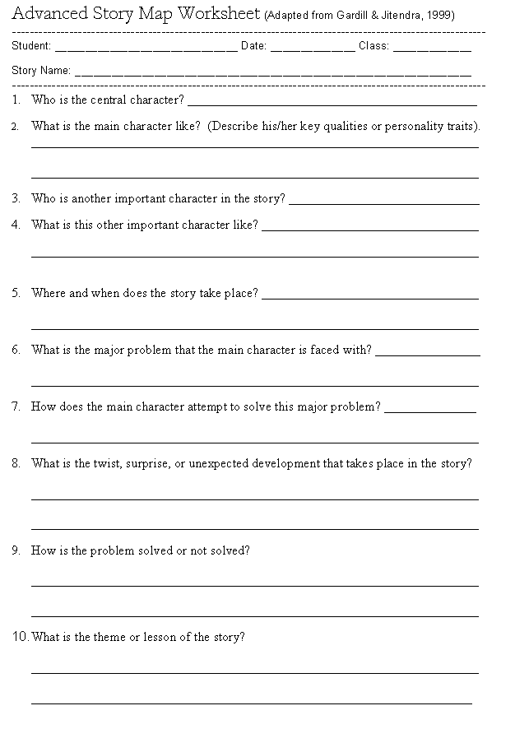

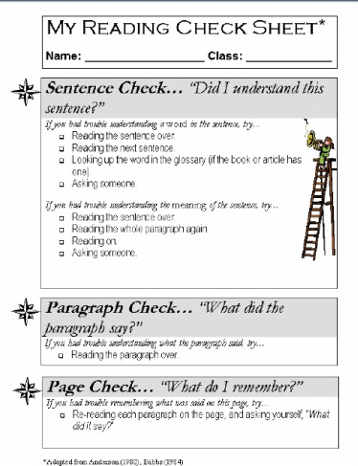

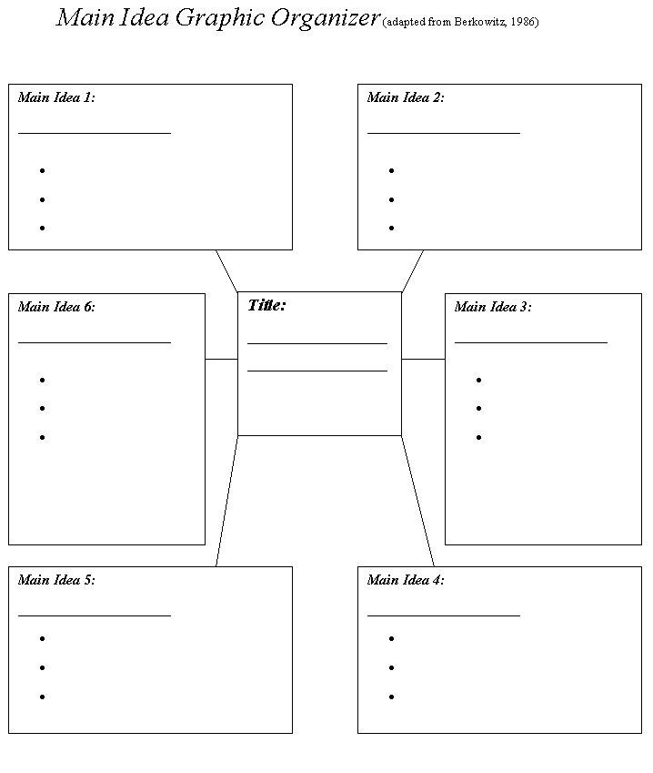

Be a Careful Reader!: Four Strategies to Better Understand What You Are Reading
When you are reading an article, book chapter, or story, you can use these four simple techniques to be sure that you fully understand the content.
Prediction. Before you begin to read the selection, look at the main title, scan the pages to read the major headings, and look at any illustrations. Based on these clues, try to predict what the article or story is about.
Now read the selection to see whether it turns out as you predicted! Stop at several points during your reading and ask yourself how closely the content of the actual story or article fit your initial prediction. How do the facts and information that you have read change your prediction about what you will find in the rest of the story or article?
List Main ideas. Stop after each paragraph or major section of the passage. Construct one or two complete sentences that sum up only the most important idea(s) that appear in the section. (Good summary sentences include key concepts or events but leave out less important details!)
Write these summary (main idea) sentences down and continue reading.
Question Generation. Look at the ideas that you have summarized as you read the passage. For each main idea listed, write down at least one question that the main idea will answer. Good questions should include words like “who, “where”, “when”, “why”, and “what”.
For example, if you are reading an article about the extinction of the dinosaurs, you might list the following main idea: “Most scientists now believe that the extinction of the dinosaurs was caused by a large meteor striking the earth.” You could then write this question: “What event do most scientists now believe caused the mass extinction of the dinosaurs?”
Clarifying. Sometimes in your reading you will run into words, phrases, or whole sentences that really don’t make sense. Here are some ways that you can clarify the meaning of your reading before moving on:
Unknown words. If you come across a word whose meaning you do not know, read the sentences before and after it to see if they give you clues to the word’s meaning. If the word is still unclear, look it up in a dictionary.
Unclear phrases or sentences. Reread the phrase or sentence carefully and try to understand it. If it contains words such as “them”, “it” or “they”, be sure that you know what nouns (persons, places, or things) to which these words refer.
If all else fails, ask another student or an adult to help you to clarify the meaning of a confusing word, phrase, or sentence.

Reciprocal Teaching Strategies Worksheet (Adapted from Lysynchuk, Pressley, & Vye, 1990)
Student Name: _______________________ Reading Assignment: __________________________ Date: ___________
Prediction. Before you begin to read the selection, look at the main title, scan the pages to read the major headings, and look at any illustrations. Write down your prediction about what the story or article will cover:
____________________________________________________________________________________________________________ ____________________________________________________________________________________________________________
List Main Ideas. As you finish reading each paragraph or key section of the passage, summarize the main idea of that paragraph or section in one or two complete sentences. (Use the back of this sheet if needed.):
Generate Questions. For each main idea listed, write down at least one question that the main idea will answer. Good questions should include words like “who, “where”, “when”, “why”, and “what”.
Main idea 1:______ ______________________________________ _______________________________________________________
Main idea 2:______ ______________________________________ _______________________________________________________

Main idea 3:______ ______________________________________ _______________________________________________________

· Question 1 :______ ______________________________________ _______________________________________________________

Question 2 :______ ______________________________________ _______________________________________________________

Question 3 :______ ______________________________________ _______________________________________________________
·
_______________________________________________________ _______________________________________________________
Clarifying. Copy down any words, phrases, or sentences in the passage that are unclear: ______________________________________________ ____________________________________________________________________________________________________________ __________________________________________________________________________________________________________

RECIPROCAL TEACHING STRATEGIES WORKSHEET

PREDICT.
Beginning of book/story: I think I will learn that __________________________________
_______________________________________________________________________
because _________________________________________________________
_______________________________________________________________________
Adjust prediction:
Page #: I think I will learn that ___________________________________
_______________________________________________________________________
because_________________________________________________________________
_______________________________________________________________________
Adjust prediction:
Page #: I think I will learn that ___________________________________
_______________________________________________________________________
because __________________________________________________________
_______________________________________________________________________
Adjust prediction:
Page #: I think I will learn that ________________________________________
_______________________________________________________________________
because ________________________________________________________________
_______________________________________________________________________

QUESTION. Here are questions I can ask my group (who, what, when, where, why, how, what if):
1. Page # ____ _______________________________________________________________________
_______________________________________________________________________
2. Page # ____ _______________________________________________________________________
_______________________________________________________________________
3. Page # ____ _______________________________________________________________________
_______________________________________________________________________
4. Page # ____ _______________________________________________________________________
_______________________________________________________________________
5. Page # ____ _______________________________________________________________________
_______________________________________________________________________
6. Page # ____ _______________________________________________________________________
_______________________________________________________________________
CLARIFY. You clarify words you don’t know and/or parts that you don’t understand in a story.
Clarifying words:
**___________ is a difficult word because ____________________________________________________.
So I (check the strategies that you used) __ checked parts of the word that I know, __ sounded out the word, __thought of a word that looks like this, __ read on to find clues, __ reread to find clues, __tried another word.
**___________ is a difficult word because ____________________________________________________.
So I (check the strategies that you used) __ checked parts of the word that I know, __ sounded out the word, __thought of a word that looks like this, __ read on to find clues, __ reread to find clues, __tried another word.
**___________ is a difficult word because ____________________________________________________.
So I (check the strategies that you used) __ checked parts of the word that I know, __ sounded out the word, __thought of a word that looks like this, __ read on to find clues, __ reread to find clues, __tried another word.
**___________ is a difficult word because ____________________________________________________.
So I (check the strategies that you used) __ checked parts of the word that I know, __ sounded out the word, __thought of a word that looks like this, __ read on to find clues, __ reread to find clues, __tried another word.
Clarifying ideas or parts of a story:
**___________________________________________________________ is a confusing idea or part because ______________________________________________________________________.
So I (check the strategies that you used) __reread, __read on, __thought about what I know, __ talked to a friend.
**___________________________________________________________ is a confusing idea or part because ____________________________________________________________________.
So I (check the strategies that you used) __reread, __read on, __thought about what I know, __ talked to a friend.
**___________________________________________________________ is a confusing idea or part because ____________________________________________________________________.
So I (check the strategies that you used) __reread, __read on, __thought about what I know, __ talked to a friend.
**___________________________________________________________ is a confusing idea or part because ___________________________________________________________________.
So I (check the strategies that you used) __reread, __read on, __thought about what I know, __ talked to a friend.

SUMMARIZE. Here is a one to three sentence summary reflecting the main/important points of the book/story: _______________________________________________________________________
_______________________________________________________________________
_______________________________________________________________________
_______________________________________________________________________
_______________________________________________________________________
_______________________________________________________________________
_______________________________________________________________________

